Homework 4

**Q1.1**

~(A⊙C + ~B ) * ~(B+D) + ~B

⊙is the symbol for XNOR

This is from Logisim and is simplified ~a b c + a b ~c

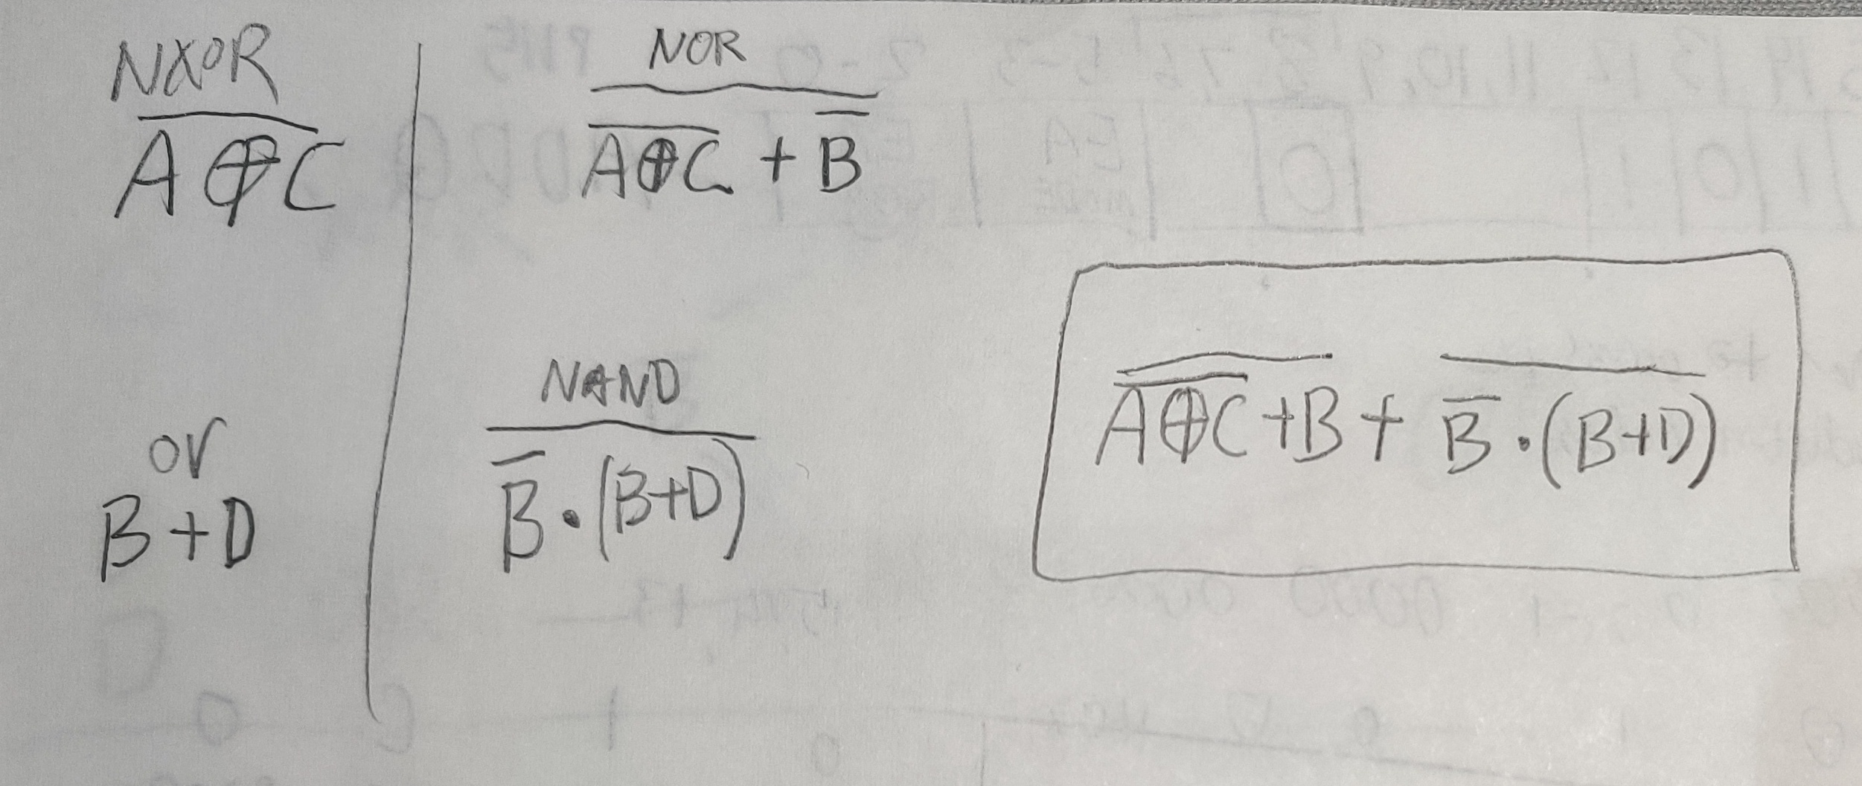

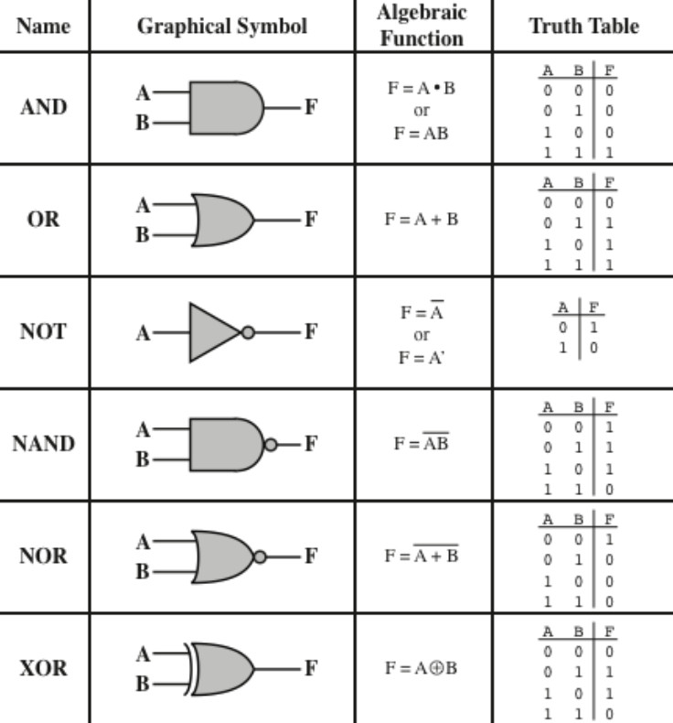**Q1.2**

|  |  |  |  |  |
| --- | --- | --- | --- | --- |
| **A** | **B** | **C** | **D** | **X / output** |
| 0 | 0 | 0 | 0 | 0 |
| 0 | 0 | 0 | 1 | 0 |
| 0 | 0 | 1 | 0 | 0 |
| 0 | 0 | 1 | 1 | 0 |
| 0 | 1 | 0 | 0 | 0 |
| 0 | 1 | 0 | 1 | 0 |
| 0 | 1 | 1 | 0 | 1 |
| 0 | 1 | 1 | 1 | 1 |
| 1 | 0 | 0 | 0 | 0 |
| 1 | 0 | 0 | 1 | 0 |
| 1 | 0 | 1 | 0 | 0 |
| 1 | 0 | 1 | 1 | 0 |
| 1 | 1 | 0 | 0 | 1 |
| 1 | 1 | 0 | 1 | 1 |
| 1 | 1 | 1 | 0 | 0 |
| 1 | 1 | 1 | 1 | 0 |

**Q3.1**

Truth table

0, 1, 2, 3 (output = +2)

4, 5, 6, 7 (output = -1)

Inputs Outputs

|  |  |  |  |  |  |
| --- | --- | --- | --- | --- | --- |
| **Z** | **Y** | **X** | **C** | **B** | **A** |
| 4’s | 2’s | 1’s | 4’s | 2’s | 1’s |
| 0 | 0 | 0 | 0 | 1 | 0 |
| 0 | 0 | 1 | 0 | 1 | 1 |
| 0 | 1 | 0 | 1 | 0 | 0 |
| 0 | 1 | 1 | 1 | 0 | 1 |
| 1 | 0 | 0 | 0 | 1 | 1 |
| 1 | 0 | 1 | 1 | 0 | 0 |
| 1 | 1 | 0 | 1 | 0 | 1 |
| 1 | 1 | 1 | 1 | 1 | 0 |

**Q3.2** **and 3.3**

Karnaugh Map

Circle a power of 2 (1, 2, 4, 8…)

(ZY 10 would be Z~Y (Z notY))

|  |  |  |  |  |  |
| --- | --- | --- | --- | --- | --- |
| **C** | | **ZY** | | | |
| **00** | **01** | **11** | **10** |
| **X** | **0** | 0 | 1 | 1 | 0 |
| **1** | 0 | 1 | 1 | 1 |

Y + Z~YX

|  |  |  |  |  |  |
| --- | --- | --- | --- | --- | --- |
| **B** | | **ZY** | | | |
| **00** | **01** | **11** | **10** |
| **X** | **0** | 1 | 0 | 0 | 1 |
| **1** | 1 | 0 | 1 | 0 |

~Z~Y + ZYX + Z~Y~X

|  |  |  |  |  |  |
| --- | --- | --- | --- | --- | --- |
| **A** | | **ZY** | | | |
| **00** | **01** | **11** | **10** |
| **X** | **0** | 0 | 0 | 1 | 1 |
| **1** | 1 | 1 | 0 | 0 |

~ZX + Z~X

**Q3.4**

See HW4Q3 file

**Q3.5**

Note, it got the ABC and XYZ backwards, and I don’t know how to change it. Also it made the inside the outside for the output (x=1’s y=2’s z=4’s). But it is correct.

a b c x y z

0 0 0 0 1 0

0 0 1 1 1 0

0 1 0 0 0 1

0 1 1 1 0 1

1 0 0 1 1 0

1 0 1 0 0 1

1 1 0 1 0 1

1 1 1 0 1 1